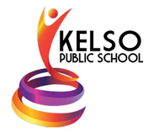
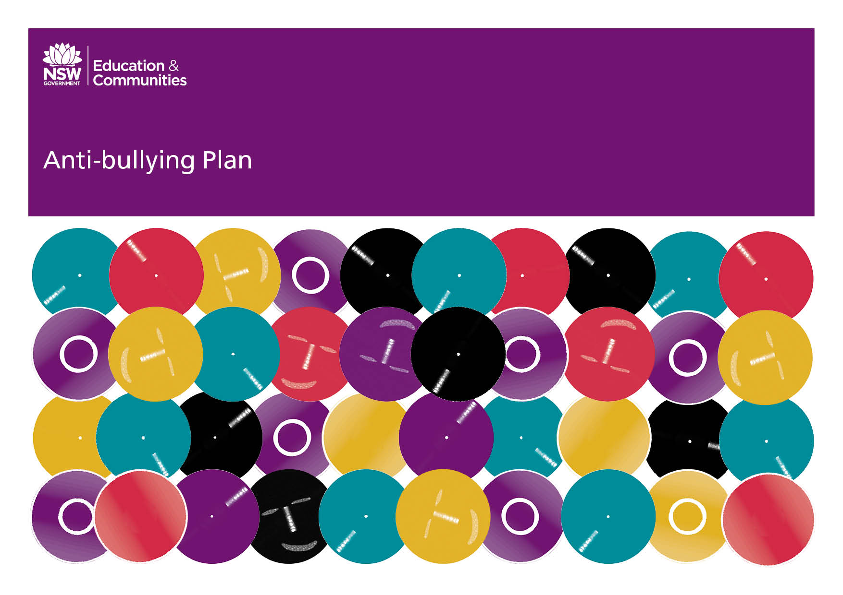
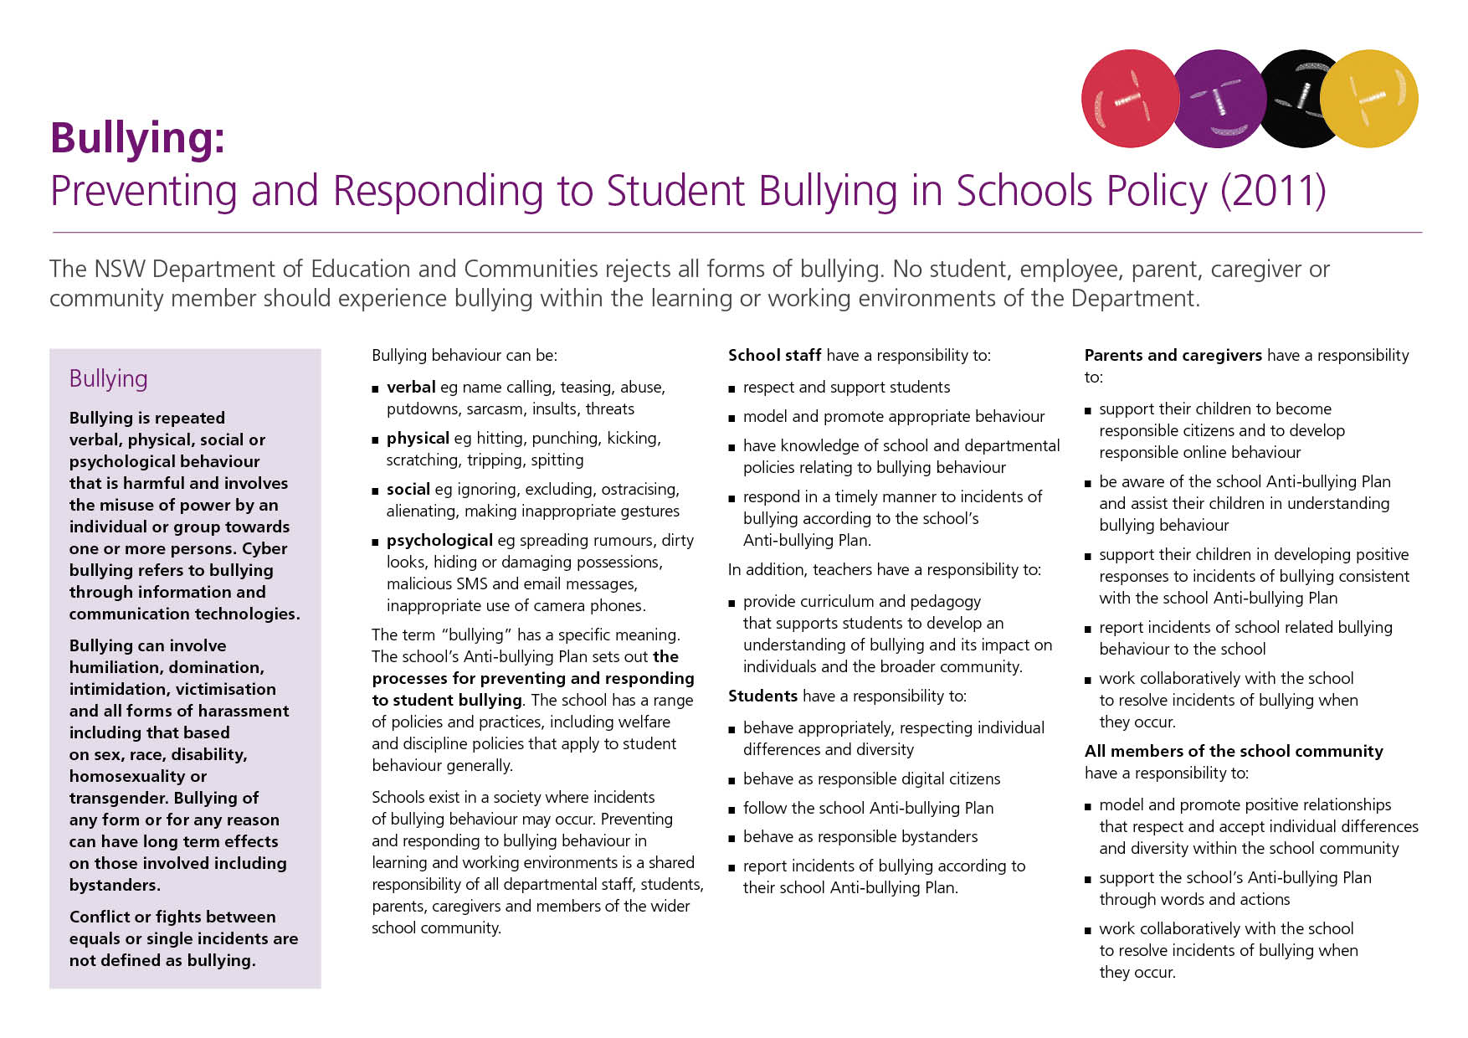
Our School Anti-Bullying Plan
Kelso Public School – 2021 (Revised 2023)

Our School Anti-Bullying Plan
This plan outlines the processes for preventing and responding to student bullying in our school and reflects the Bullying: Preventing and Responding to Student Bullying in Schools Policy of the New South Wales Department of Education and Communities.
Kelso Public School’s Anti-Bullying Policy defines the rights and responsibilities of students, staff and parents so that the whole school community is able to co-operate and support the policy guidelines. The Anti-bullying Plan is available on the school website so it is accessible to all families. New families will be given a paper copy of the plan as part of their enrollment form and information on our Anti-bullying plan will be provided to new kindergarten families as part of our parent information sessions and orientation program. Teachers will ensure the rights and responsibilities are discussed with their students at the beginning of each year, and at selected times throughout the year, to ensure maximum understanding.
All members of the school community contribute to the prevention of bullying by modelling and promoting appropriate behaviour and respectful relationships.
Statement of Purpose
Schools exist in a society where incidents of bullying behaviour may occur. Preventing and responding to bullying behaviour in learning and working environments is a shared responsibility of all departmental staff, students, parents, caregivers and members of the wider school community.

At Kelso Public School we believe that learning is a lifelong process. Within our school community, each member is recognised as an individual with potential skills, abilities and gifts, which need to be shared, developed and valued. This will occur in a cohesive, supportive, safe, fun, happy and stimulating environment with the support of our strong student wellbeing programs. At Kelso Public School, creativity and flexibility are encouraged and respected. We do not tolerate bullying or harassment in any form and are committed to dealing effectively with incidences as they arise.

Protection
At Kelso Public School we have identified bullying as follows:

Bullying is repeated verbal, physical, social, or psychological behaviour that is harmful and involves the misuse of power by an individual or group towards one or more persons. It can have long-term effects on those involved.
Bullying can happen:

- face-to-face (e.g., pushing, tripping, name-calling).
- at a distance (e.g., spreading rumours, excluding someone).
- through information and communications technologies (e.g. use of SMS, email, social media platforms, chat rooms).

Some conflicts between children are a normal part of growing up and are to be expected. These conflicts or fights between equals and single incidents are not considered bullying, even though they may be upsetting and need to be resolved.
Identifying bullying can sometimes be difficult. Bullying is often conducted out of sight of teachers and children may be reluctant to report bullying.
Cyber-bullying refers to bullying through information and communication technologies. Cyber-bullying can be carried out through an internet service such as:
- email.
- chat room.
- discussion group or forum.
- instant messaging.
- social networking websites such as Instagram, Facebook, or YouTube.

Cyber-bullying can also include bullying through mobile phones by:
- text and picture messaging.
- video clips.
- phone calls.

The incidence of electronic bullying is ever increasing as students have greater access to mobile phones and the internet. Students are not allowed to access social networking sites such as Facebook, YouTube, snapchat or Instagram or any such new innovations within social networking at Kelso Public School. All mobile phones are handed in at the office by students at the beginning of the school day and retrieved at the end. A Mobile Phone Agreement is signed by students when a student first brings in a mobile phone. Should an incident of bullying involving an electronic medium occur at school then the school will deal with the issue by following the Cyber Safety Policy and the School Behaviour Management Policy.

Where incidents of cyber-bullying are impacting on the learning of any student, the staff at Kelso Public School will respond to these incidents depending upon the circumstances and the content of the cyber-bullying.

Cyber-safety
Teaching your child to be cyber-safe will help them to engage with the online world safely and positively and protect them from online risks.

Prevention
Early Intervention
In a safe and supportive school, the risk from all types of harm is minimised, diversity is valued and all members of the school community feel respected and included and can be confident that they will receive support in the face of any threats to their safety or wellbeing.
At Kelso Public School we promote and provide a supportive learning community where all students feel, and are safe. Students have a fundamental right to learn in a safe, supportive environment and to be treated with respect. Similarly, parents and other local community members have the right to feel safe, supported and respected within the school content.

School communities working together with staff, students and families can recognise, challenge and address issues that arise within the school.
At Kelso Public School we believe the following to be the most effective in preventing and reducing bullying:
- A whole-school approach that includes the explicit teaching of anti-bullying skills and the implementation of Positive Behaviour for Learning strategies to promote positive relationships.
- An increased awareness of bullying in the school community through assemblies, ‘Everybody Matters Week” and other focus days.
- A whole-school detailed policy that addresses bullying.
- The use of SENTRAL software to document and monitor incidents of bullying.
- Effective classroom management and classroom rules.
- The promotion of a positive school environment that provides safety, security and support for students and promotes positive relationships and student wellbeing.
- Encouragement and skill development for all students (and especially bystanders) to respond negatively to bullying behaviour and support students who are bullied.
- A reward system based on positive reinforcement including: Positive Behaviour for Learning (PBL), PBL Reward Days and Assembly Awards.

Early intervention may be provided by:
Early intervention strategies and programs that Kelso Public School will implement for students who are identified as having experienced bullying, at risk of being bullied or have engaged in bullying behaviour include:
- The provision of parenting sessions and support.
- Involvement of allied school staff (e.g. school psychologist or counsellor, student welfare, well-being officer, School Chaplains, school nurse, speech therapist, occupational therapists, mental health providers) to ensure early intervention and support is made available.
- Referral to Learning Support Team.
- Using social stories and role play situations.

Response
In responding to incidents of bullying the following factors must be considered by all parties involved:
- Interventions need to be matched to the particular incident of bullying.
- No method of addressing bullying has been reported as 100% effective.
- More than one intervention will usually need to be implemented.
- No one intervention is appropriate in all circumstances of bullying.
- Not all hurtful behaviours are bullying, but schools address inappropriate behaviour whether or not it meets the definition of bullying.
- At NO stage should a parent approach another student or student’s parent regarding issues of bullying including to and from school; these incidents will be dealt with under the DoE Policy for Reporting Incidents Involving Assaults, Threats, Intimidation or Harassment.

Kindergarten Buddy Systems
A Kindergarten Buddy System is adopted each year to promote friendship and support between year six and kindergarten peers through collaboration between their classes, which fosters a sense of whole-school community during whole school events.

Structured Playground Program – Interest Groups
This program provides alternative activities for those students who find the usual playground challenging. At first break and second break time there is one organised activity, usually one active and the other more passive. Activities are run and supervised by teachers and SRC members.

Mediation
Assisting the students involved in incidents of bullying to resolve their differences and helping them find a peaceful win-win solution or compromise. Mediation is a suitable intervention only when the imbalance of power between the students involved is not great and when each party has something to gain and to concede. It should always be voluntary and should never be used in cases of major disputes, serious bullying or assault.

Restorative Practice
Restorative Practice is a teaching and learning approach that promotes self-regulation and encourages behaviour that is supportive and respectful. It puts the onus on individuals to be truly accountable for their behaviour and to repair any harm caused to others as a result of their actions. When schools are restorative they;
• value quality relationships
• model empathy and respectful relationships
• value student voice and utilise collaborative problem solving
• view inappropriate behaviours as opportunities for learning
• apply procedural fairness

• recognise the importance of repairing damaged relationships

• use active listening and positive language and tone

• avoid scolding, judging, lecturing or blaming

• foster self-awareness in the student

• implement consequences that are proportional and fair

• remain future focused.

Traditional Disciplinary Approach
Setting out clear behaviour standards and using appropriate and realistic consequences to prevent and deter the student from repeating their behaviour. Such consequences may include reflection, reset room, loss of privileges, restricted play areas (playground roster) parent meetings, suspension, negotiated attendance or even exclusion from the school. The reset room is specifically run to work with individual students developing social skills, emotional regulation and positive relationships.

Executive counselling

Executive counselling is a K-6 strategy used for managing student behaviour in the playground and classroom. It operates as needed with students and their Assistant Principal on stage/Deputy Principal and Principal when required.. These sessions give the Stage supervisor the opportunity to resolve playground and classroom issues that can’t be resolved directly by the teacher on duty or in the classroom. It enables staff time to counsel and mentor students who are experiencing difficulties in the playground or classroom, to exclude certain students who repeatedly disregard the rights of others, and to resolve complex issues in a manner that is fair to everyone involved after gathering all of the facts.
Students may be referred for the following behaviours:

- Bullying.
- Continual non-compliance / defiance.
- Swearing and verbal.
- Refusal to follow the teachers instructions.
- Refusal to complete set class work.
- Deliberate disruption to class learning.
- Dangerous behaviours to self or others.
- Fighting.
- Willful damage to property.
- Stealing.
- Teasing / Tormenting.
- Consistently out of bounds.

On some occasions these counselling sessions may be conducted by the Principal, depending on the severity of the incident or behaviour.
Persistent misbehavior, or for more serious incidents (such as physical aggression), a warning of suspension or actual suspension may apply as outlined in the DoE “Procedures for the Suspension & Expulsion of School Students.”
If an incident of bullying occurs at Kelso Public School we use Prevention, Intervention and Post-intervention strategies.

Prevention strategies include:
- Promoting the school’s core values of Be Safe, Be Respectful, Be Responsible, Be On Task and Be Proud at morning assemblies and during class time.
- Using the curriculum to teach students about respectful relationships, civics and citizenship.
- Developing programs to help students participate and have a say in their learning (e.g. Student Surveys).
- Teaching students about violence prevention, conflict resolution, anger management and problem-solving strategies as part of anti-bullying units and PBL lessons.
- Teaching for and about diversity and acceptance.
- Providing school-based professional learning for staff addressing their identification and response to bullying.
- Regular Learning Support Team (LST), staff and stage meetings where issues of student welfare are discussed on an ongoing basis.

Intervention strategies include:
- Counselling students who have been bullied.
- Talking with parents or caregivers about the situation.
- Putting appropriate consequences in place for those who bully others (e.g. Executive Counselling / Warning of Suspension).
- Ensuring that all staff know how to address bullying effectively and respectfully.
- Life education van.
- Year 6-Kindergarten buddy program.
- Year 6-7 Transition program with Denison College.
- Classroom rules, routines and processes negotiated and applied consistently.

Post-intervention strategies include:
- Monitoring the situation between the students to ensure that their safety and well-being are maintained.
- Talking with parents or caregivers about the school’s anti-bullying strategies as part of Term One/Four Parent Information Sessions and on a needs basis throughout the year.
- Restricted areas if required (playground roster).
- Reviewing and evaluating student wellbeing policies and strategies each term.
- Monitoring student wellbeing through consistent centralised tracking system data eg Sentral.

Signs that your child may be being bullied:

- Dislike and avoidance of school
- Decline in academic performance and/or social interaction
- Is getting into trouble more at school
- Wants to be taken to school even though its close
- Would prefer to walk rather than catch the bus
- Possessions are damaged or missing
- Becoming withdrawn, appearing depressed or anxious
- Unable to explain bruises or scratches
- Complaints of feeling unwell
- Has reoccurring bad dreams
- Uses put down language when speaking about others
- Increased negative self-perception

Signs that your child may be bullying others:

- Aggressive behaviour (teasing, threatening, hurting others
- Difficult to manage
- Oversensitive (feels that everyone is out to get him/her
- Unhappiness
- Loses temper often
- Quietness or depression symptoms
- Decline in academic performance
- Sensing that other parents are avoiding you or hinting at things that you are unaware of

Procedures for reporting and responding to bullying

- Students report all incidents of bullying to a teacher immediately
- Parents with concerns about bullying should make an appointment to talk to classroom teacher immediately or as soon as practically possible
- All bullying incidents are to be reported, taken seriously and dealt with by classroom teachers, Assistant Principal/Deputy Principal and Principal (depending on severity)

Teachers will contact the parents of the student being bullied and the student engaging in the bullying immediately after it is discovered. All staff will then be informed so students can be monitored on the playground. In the case of cyber bullying, the police may need to be contacted to make a report.

Students who have been or are at risk of being a victim of ongoing bullying will be referred to the Learning Support Team for support from the school counsellor.

Reporting Incidents Involving Assaults, Threats, Intimidation or Harassment

An incident is broadly defined in the Department’s Incident Reporting Policy as an event which:
- Causes disruption to an organisation, or
- Creates danger or risk that could significantly affect individuals within the organisation, or
- Impacts on the effective operation of the workplace, or
- Attracts negative media attention or a negative public profile for the workplace or the Department of Education and Training, or
- Workcover describes as a “serious incident” which must be reported by law.

Such incidents that involve assaults, threats, weapons, illegal drugs and criminal activity will be reported to the School Safety and Response Hotline on 1300 363 778. These incidents will be reported to the Hotline as soon as possible, within 24 hours of the incident occurring.

If a student is injured or threatened in the course of an assault at school, or while travelling to or from school if the incident is connected to the school, the principal will notify the Police. The Police will be notified regardless of whether parents, carers or students indicate that they do not want police involvement. It is not the responsibility of parents or carers to report school related incidents to police, although they also may choose to do so.

Additional Information

The Anti-Bullying Plan will be available through the school website and regular information will be communicated through the school newsletter, P & C meetings and parent information sessions.
The school will evaluate the Anti-bullying Plan annually in term four. Parent feedback by way of survey will be utilised when evaluating and reviewing the Anti-Bullying Plan.

Useful websites
- NSW DoE Anti-bullying: https://education.nsw.gov.au/student-wellbeing/attendance-behaviour-and-engagement/anti-bullying/nsw-anti-bullying
- Kids Helpline: https://kidshelpline.com.au/
- Digital Citizenship: http://www.digitalcitizenship.nsw.edu.au/
- Bullying. No way! website: http://www.bullyingnoway.gov.au
- eSafetyeducation: https://www.esafety.gov.au/educators
- Friendly schools friendly families:
- https://www.communitiesthatcare.org.au/friendly-schools-and-familiesfriendly-schools-plus

Documents
- Bullying of Students - Prevention and Response Policy: https://policies.education.nsw.gov.au/policy-library/policies/pd-2010-0415
- Restorative Practice - A pro-social approach to resolving conflict:
https://education.nsw.gov.au/content/dam/main-education/student-wellbeing/attendance-behaviour-and-engagement/media/documents/Restorative-Practice-fact-sheet.pdf

Additional Support Services may include:
- Police Youth Liaison Officer (Bathurst Police – (02) 6332 8699
- Department of Communities and Justice– (02) 6333 0000
- Child Well Being Unit – 1300 480 420
- Kids Helpline 1800 55 1800
- Lifeline 13 11 14
Principal’s Comment

School Contact Information
Kelso Public School
19 Gilmour St,
Kelso, 2795
Phone: 02 6331 1577
Email: kelso-p.school@det.nsw.edu.au
Website : http://www.kelso-p.schools.nsw.edu.au/

